Practical 9: Pointer and Dynamic Memory Allocation

1. Add two matrix using Pointers.(A)
#include <stdio.h>
void addMatrices(int *mat1, int *mat2, int *result, int rows, int cols) {
for (int i = 0; i < rows; i++) {
for (int j = 0; j < cols; j++) {
*(result + i * cols + j) = *(mat1 + i * cols + j) + *(mat2 + i * cols + j);
}
}
}
int main() {
int rows = 2, cols = 2;
int mat1[2][2] = {{1, 2}, {3, 4}};
int mat2[2][2] = {{5, 6}, {7, 8}};
int result[2][2];

addMatrices((int *)mat1, (int *)mat2, (int *)result, rows, cols);

printf("Resultant Matrix:\n");
for (int i = 0; i < rows; i++) {
for (int j = 0; j < cols; j++) {
printf("%d ", result[i][j]);
}
printf("\n");
}
return 0;
}
Output:-
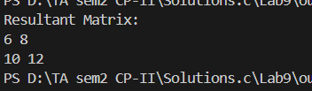

2. Print sum of columns of a matrix using Pointers.(A)
#include <stdio.h>
void columnSum(int *matrix, int rows, int cols) {
for (int j = 0; j < cols; j++) {
int sum = 0;
for (int i = 0; i < rows; i++) {
sum += *(matrix + i * cols + j);
}
printf("Sum of column %d: %d\n", j + 1, sum);
}
}
int main() {
int rows = 3, cols = 3;
int matrix[3][3] = {{1, 2, 3}, {4, 5, 6}, {7, 8, 9}};
columnSum((int *)matrix, rows, cols);
return 0;
}
Output:-
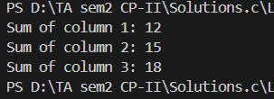

3. Find length of string using Pointers.(A)
#include <stdio.h>
int stringLength(char *str) {
char *ptr = str;
int length = 0;
while (*ptr != '\0') {
length++;
ptr++;
}
return length;
}
int main() {
char str[] = "Hello, World!";
printf("Length of the string: %d\n", stringLength(str));
return 0;
}
Output:-
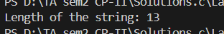

4. Copy one string into another string using Pointers.(A)
#include <stdio.h>
void copyString(char *source, char *destination) {
while (*source != '\0') {
*destination = *source;
source++;
destination++;
}
*destination = '\0'; // Null terminate the destination string
}
int main() {
char source[] = "Hello, World!";
char destination[50];
copyString(source, destination);
printf("Copied String: %s\n", destination);
return 0;
}
Output:-
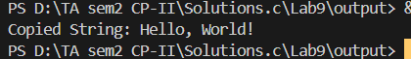

5. Find Maximum Element in a 2-D Array Using Pointers.(B)
#include <stdio.h>
int findMax(int *matrix, int rows, int cols) {
int max = *matrix;
for (int i = 0; i < rows; i++) {
for (int j = 0; j < cols; j++) {
if (*(matrix + i * cols + j) > max) {
max = *(matrix + i * cols + j);
}
}
}
return max;
}
int main() {
int rows = 3, cols = 3;
int matrix[3][3] = {{1, 5, 3}, {8, 2, 6}, {4, 7, 9}};
printf("Maximum Element: %d\n", findMax((int *)matrix, rows, cols));
return 0;
}
Output:-
